LAB Assignment

Submitted by -
Name: Shah Alam Abir
Roll: BSSE-1439
E-mail: bsse1439@iit.du.ac.bd

Submitted to -
Name: Dr. Md. Shariful Islam
Professor, Institute of Information Technology, University of Dhaka
Email: shariful@iit.du.ac.bd

1. nslookup

1. Run nslookup httpd.apache.org. IP Address of this server is 151.101.2.132

2. Run nslookup -type=NS cam.ac.uk to get all the authoritative servers of University of Cambridge. List of authoritative DNS servers of University of Cambridge is -
1. cam.ac.uk nameserver = ns3.mythic-beasts.com.
2. cam.ac.uk nameserver = ns2.ic.ac.uk.
3. cam.ac.uk nameserver = dns0.cl.cam.ac.uk.
4. cam.ac.uk nameserver = auth0.dns.cam.ac.uk.
5. cam.ac.uk nameserver = dns0.eng.cam.ac.uk.
6. cam.ac.uk nameserver = ns1.mythic-beasts.com.

3. There is no DNS server obtained in Question 2 that could queried for the mail server for Yahoo! Mail. Yahoo! Mail can be queried from these servers
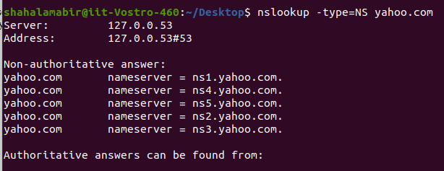
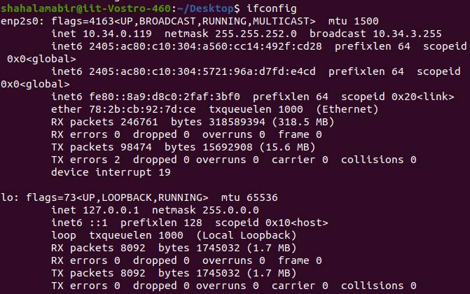
2. ifconfig

3. Tracing DNS with Wireshark

4.
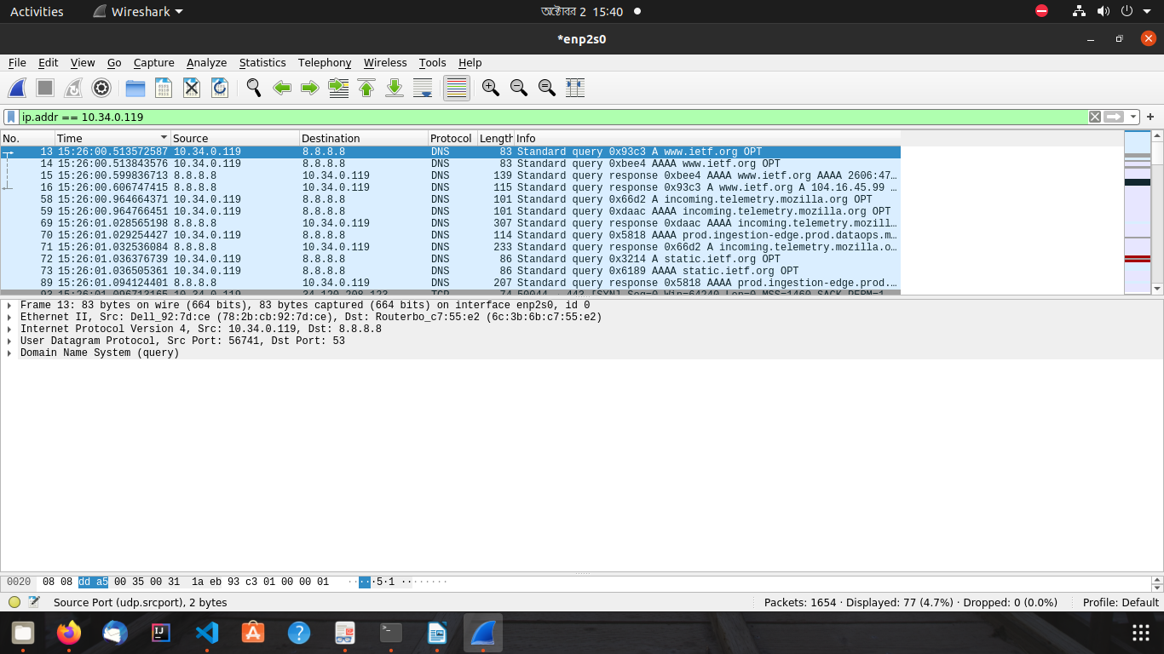
These query and responses were sent over UDP.

5. Destination port for DNS query message is 53. Source port for the DNS response message is 53.

6. DNS query message has sent to IP Address 8.8.8.8. IP Address of my local DNS server is also 8.8.8.8. Both of them are same
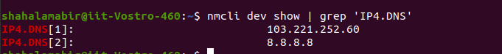
7. First DNS query is of type A. Second DNS query is of type AAAA. No, none of this two DNS query messages contains any “answers”.

8. There are two “answers” provided in both of the DNS response messages.

